**When:**

Thursday 8, Friday 9, and Wednesday 14 October 2020

#### **Where:**

**Online via video-conferencing**

**Timing:**

**1pm to 4:45pm**

**Programme Facilitators:**

Dr Mima Simic, *Joint Head of MCCAED, Consultant Child & Adolescent Psychiatrist*

Katrina Hunt,*Consultant Clinical Psychologist*

Julian Baudinet,*Principal Clinical Psychologist*

Stamatoula Voulgari, *Principal Systemic Family Psychotherapist*

Juliet Rosewall,*Senior Clinical Psychologist*

**Family and Multi-family Therapy for Bulimia Nervosa**

**(FT-BN and MFT-BN)**

**Family and Multi-family Therapy Approaches to the Treatment of Adolescent Bulimia Nervosa**

**Background:**

**Family and Multi-family Therapy for bulimia nervosa (FT-BN & MFT-BN)**

This training will focus on the Maudsley Centre for Child and Adolescent Eating Disorders (MCCAED) approach to working with young people and families with bulimia nervosa. Our service is nationally and internationally recognised for its clinical and research excellence in eating disorders, including the development of effective single family (FT-BN) and multi-family therapy (MFT-BN) treatments for adolescent bulimia nervosa. Both FT-BN and MFT-BN draw on many of the aspects of our treatments for anorexia nervosa; however, treatments for bulimia nervosa are modified to address specific psychological needs of young people with BN and their families. Family treatments for BN have integrated family therapy and multi-family principles with key elements of Attachment based Family Therapy (ABFT), Cognitive Behavioural Therapy (CBT) and concepts of emotional regulation and distress tolerance drawn from Dialectical Behaviour Therapy (DBT). FT-BN is the recommended first line treatment for adolescent bulimia nervosa (NICE, 2017). While empirical evaluation of MFT-BN is limited at present, the initial feedback from the families and the young people involved in this treatment is very positive. In addition, our MFT-BN pilot study indicates significant reductions in eating disorder symptoms and depression, increased use of adaptive coping skills in young people and improved mental health wellbeing of parents.

/var/folders/vl/cztw6yys6fn2q80c454pnd_00000gn/T/com.microsoft.Word/WebArchiveCopyPasteTempFiles/cidimage001.png@01D528ED.E8A2A0F0**Aims of this programme:**

* To promote evidence-based practice in the treatment of Eating Disorder (NICE Guidelines, 2017) for adolescent bulimia nervosa.
* To present the research and theoretical underpinning of the Maudsley approach to adolescent BN and to illustrate how the theory relates to the practice.
* To offer an overview of the ethos, theoretical and   
  clinical base for the approach with a strong emphasis on multi-disciplinary team (MDT) working.
* To illustrate through experiential group participation how families engage in treatment by using psychoeducation and teaching of emotional regulation and distress tolerance skills relevant to treating eating disorders.
* To provide participants with the skills, knowledge   
  and confidence in order to apply this model to their   
  relevant clinical setting.

**What the programme offers:**

The training consists of a 3 half-day intensive programme with a combination of didactic and experiential components, including case discussion.

**On request, we can provide continuous supervision and consultation for teams trained as separate tariffs.**

**Key outcome:**

At the end of the training participants will have the skills and competencies required to be able to apply the approach in their own clinical setting.

Our trainings promote the development of a MDT approach ethos; therefore, we encourage and prioritise teams who attend with more than one professional from each team. We recommend early booking to guarantee a place and thus avoid disappointment.

**Cost:**

**3 * 1/2 -Day intensive programme**

**£320.00 per person** – including materials and refreshments

*Teams who attend with three or more colleagues will receive an additional discount per person*.

**Who can apply:**

This training is for clinicians working within a multi-disciplinary child and adolescent eating disorders team, who hold clinical responsibility (i.e. Psychiatrists, Family Therapists, Psychologists, Psychotherapists, and Nurse Specialists). Dieticians, Paediatricians and other professionals working within the team could attend with their colleagues.

­­­­

*For enquiries, or to apply, please contact   
the training administrator:*

**Email:** MCCAEDtraining@slam.nhs.uk

**Telephone:** 020 3228 8141

**Training Manager:**

Stamatoula Voulgari,

Principal Systemic Family Psychotherapist

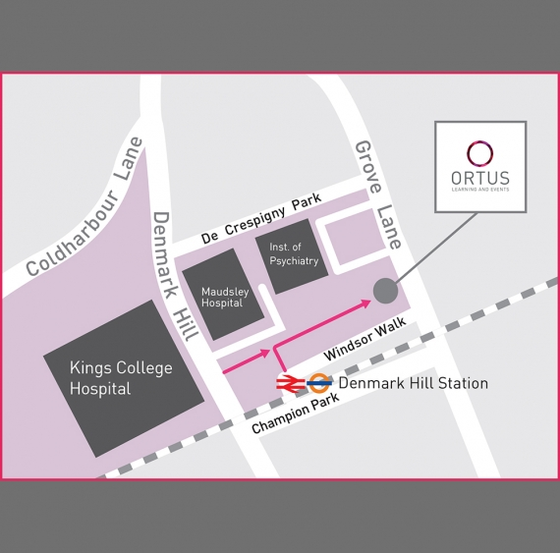



#### ORTUS Training Centre, The Maudsley Hospital site.