**When:**

Monday 16, Tuesday 17 and Wednesday 25 November 2020

**Where:**

**Online via teleconferencing**

**Timing:**

**1pm to 4:45pm**

**Programme Facilitators:**Dr Lucy Taylor, *Consultant Psychologist*Dr Mima Simic, *Consultant Child and Adolescent Psychiatrist*

**Cutting Down:**

**A CBT approach for the assessment and treatment of young people who self-harm**

**Background:**

**The Cutting Down** is a manualised CBT model for working with young people who self-harm and engage in suicidal behaviours. The Cutting Down manualised CBT workbook was developed as a brief 14-session treatment programme for young people and 5 sessions for their parents/carers. It integrates techniques from traditional CBT, ACT and DBT models. The programme addresses symptoms of depression and anxiety and other maintaining factors to self-harm. It teaches young people and their parents/carers adaptive skills to address emotional difficulties that contribute to self-harm.

**The Cutting Down** manual has five parts, broadly divided into assessment of self-harm, and motivation strategies, followed by behavioural and cognitive strategies for depression, emotion-based work, alongside ACT based work in dealing with thoughts and feelings. The main coping strategies are covered in Part three, ending with relapse prevention and moving forwards. The fifth part is the parent/carer sessions delivered alongside the young person work and also incorporates family therapy ideas. The manual offers specific evidence-based skills for self-harm, such as problem-solving, improved communication and anger, anxiety and hopelessness management.

Feedback from therapists and young people who have used the manual has been very positive and RCT evidence suggests that the treatment can reduce self-harm in a shorter space of time compared to treatment as usual.

**Aims of this Programme:**

* To present the research and theoretical underpinning of this manualised approach and to illustrate how the theory relates to the development of a CBT programme for working with young people who self-harm in addition to parents’ sessions.
* To provide participants with the skills, knowledge and confidence to apply this model and programme to young people who present with self-harm, in their relevant clinical setting.
* To promote the delivery of a more consistent, evidence-based and brief approach to the treatment of self-harm in young people.  In particular, to be able to offer a flexible and formulation driven model.
* To illustrate through discussion, teaching, role-play and practice (facilitative group participation) how therapists can offer young people and their parents/carers a thorough and robust assessment and treatment package for self-harm and associated emotional problems.

**What the Programme Offers:**

This three half-day workshop will focus on the practical application of cognitive-behavioural techniques for self-harm. The workshop will be very participative, involve a summary of the relevant literature and a manual based approach to working with this client group. Participants will have an opportunity to learn and practice skills from all the module and become proficient at a practical and accessible approach to working with clients who self-harm.

**Key Outcome:**

* At the end of the training participants will be familiar with a CBT based approach that draws on other evidence-based models, including ACT and DBT (no prior knowledge of DBT necessary) and focuses on maintaining factors to self-harm (including symptoms of depression and anxiety)
* This training will equip participants to apply a flexible and formulation driven model supported with the use of worksheets and hand-outs.

**Who can apply:**

This training is suitable for CAMHS staff and other therapists/clinicians working with young people who self-harm. The presenters will assume that professionals attending will have a basic understanding of Cognitive Behavioural Therapy (CBT).

**Cost:**

**3*1/2 day workshop**

**£320 per person**

*Teams who attend with 3 or more colleagues will receive an additional discount per person*

Our trainings are very popular, and we normally encourage the attendance of more than one professional from each team. We recommend early booking to guarantee a place and thus avoid disappointment.

­­­­

*For enquiries or to apply please contact   
the training administrator*

**Email:** MCCAEDtraining@slam.nhs.uk

**Telephone:** 020 3228 8141

**Training Manager:**

Stamatoula Voulgari,

Principal Systemic Family Psychotherapist



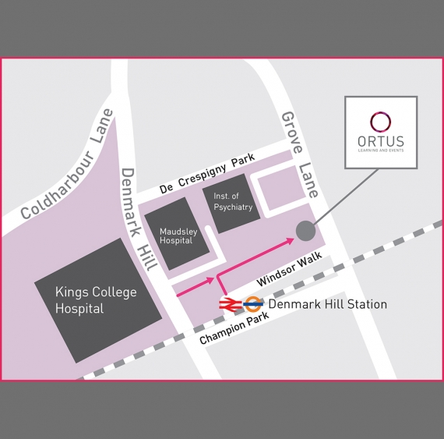

#### ORTUS Training Centre, The Maudsley Hospital site.