**When:**

Wednesday 15 July 2020

#### Where:

**Online via video-conferencing**

**Programme Facilitator:**

**Rachel Bryant-Waugh**

Consultant Clinical Psychologist

ARFID Service Lead

**Pica, ARFID, and Rumination Disorder Interview (PARDI) Training**

**Background:**

PARDI is available in 4 formats: for parents/carers of children aged 2-3 years; for parents/carers of those aged 4 years and above; for individuals 8-13 years; and for individuals aged 14 years and above.

It is the most detailed assessment instrument available for the disorders it covers, and designed to complement the Eating Disorders Examination in its utility and scope. The PARDI includes diagnostic algorithms for pica, ARFID and rumination disorder, severity scores for all three disorders, and profile scores tapping interest in food and eating, sensory based avoidance, and concern about aversive consequences of eating, in ARFID.

This one day training is led by Rachel Bryant-Waugh, the lead author on the development of the PARDI.

**What the Programme Offers:**

The training includes an orientation to the measure, its uses, how to generate a diagnoses and profile scores, and an item by item discussion of content and ratings.

**Key Outcome:**

At the end of the training participants will have the skills and competencies required to be able to use the PARDI in clinical and research settings.

**Cost:**

**1-day programme**

**£200.00 per person** – including materials.

**Who can apply:**

This training is for clinicians and researchers working with children and young people under 18 years of age.

­­­

#### *ORTUS Training Centre, The Maudsley Hospital site.*

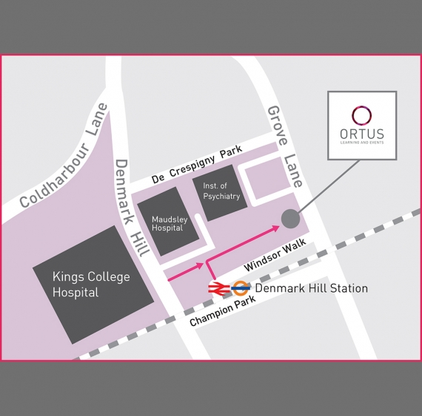

*For enquiries or to apply please contact   
the training administrator*

**Email:** MCCAEDtraining@slam.nhs.uk

**Telephone:** 020 3228 8141

**Training Manager:**

Stamatoula Voulgari,

Principal Systemic Family Psychotherapist

**Email:** [stamatoula.voulgari@slam.nhs.uk](mailto:stamatoula.voulgari@slam.nhs.uk)

