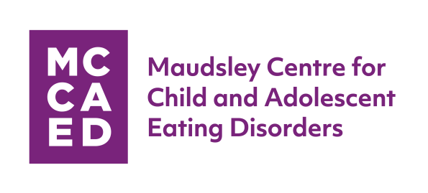
Attachment-Based Family Therapy (ABFT):
When:
Monday 26 October 2020
Where:
Maudsley Learning, ORTUS learning and events
centre. 82 – 96 Grove Lane, London, SE5 8SN

Programme Facilitator:
Guy S. Diamond
Professor Emeritus at University of Pennsylvania School of Medicine; Associate Professor at Drexel University in the College of Nursing and Health Professions

Introductory Workshop One Day Training

Background:
ABFT is a manualised, empirically supported family therapy model specifically designed to target family and individual processes associated with adolescent suicide and depression. ABFT emerges from interpersonal theories that suggest adolescent and young adult internalising disorders (e.g. depression, suicide, trauma) can be precipitated, exacerbated or buffered against by the quality of interpersonal relationships in families. It has also been used where family conflict is a contributor to the presenting problem. It is a trust-based, emotion-focused psychotherapy model that aims to repair interpersonal ruptures and rebuild an emotionally protective, secure-based parent–child relationship. In this workshop, you will learn about the theoretical principles ABFT is based on as well as the clinical strategies that comprise ABFT.

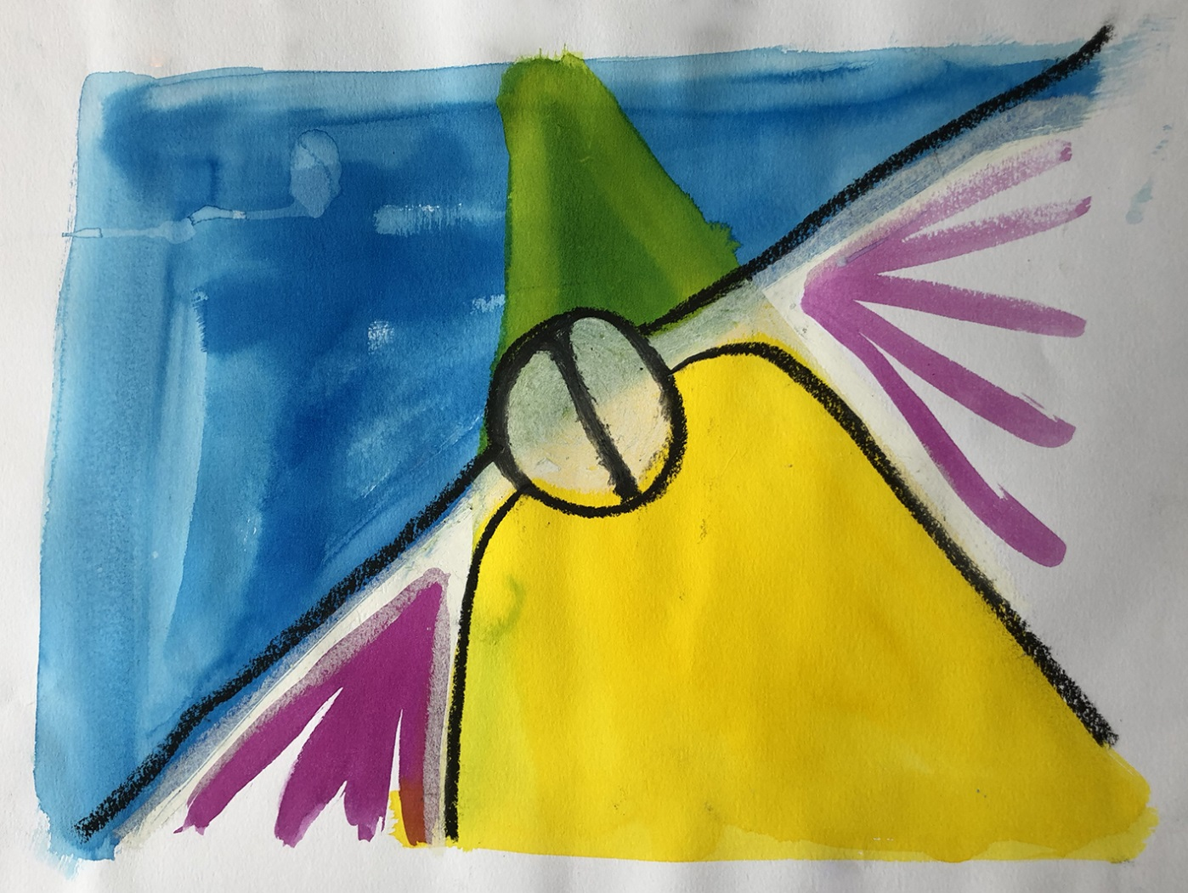
Aims of this Programme:
During this one-day workshop, we will offer an overview of the model including theoretical principles and clinical strategies. Faculty will review how attachment theory, emotion regulation, and trauma resolution inform the delivery of this experiential treatment approach. We also review the goals and structure of the five treatment tasks that provide a road map for delivering this interpersonally focused psychotherapy effectively and rapidly.

Facilitator: Guy S. Diamond, PhD
Guy Diamond, PhD is Professor Emeritus at the University of Pennsylvania School of Medicine and Associate Professor at Drexel University in the College of Nursing and Health Professions. At Drexel, he is the Director of the Centre for Family Intervention Science (CFIS) and the former Director of the PhD program in Couple and Family Therapy. Dr. Diamond is the primary developer of Attachment-Based Family Therapy. He has received several federal, state and foundation grants to develop and test this model. Along with his co-authors, Drs. Gary Diamond and Suzanne Levy, Dr. Diamond has written the first book on ABFT, Attachment-Based Family Therapy for Depressed Adolescents, published by the American Psychological Association on October 2013.

Cost:
1 day introductory programme
£120.00 per person including materials and refreshments.
£100 per person - early bird registrations before August 31st.

Who can Apply:
Counsellors, Family Therapists, Doctors, Mental Health Professionals, Psychiatrists, Psychologists, Psychotherapists, Social Workers, and CYP-IAPT Practitioners.

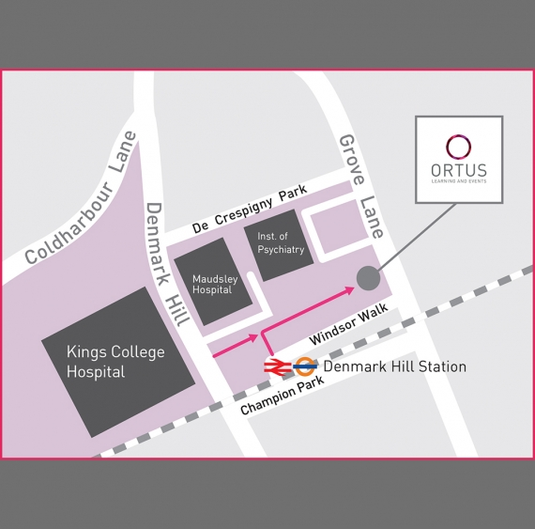

ORTUS Training Centre, The Maudsley Hospital site.

For enquiries or to apply please contact
the training administrator:
Email: MCCAEDtraining@slam.nhs.uk
Telephone: 020 3228 8141
https://mccaed.slam.nhs.uk/

Training Manager:
Stamatoula Voulgari,
Principal Systemic Family Psychotherapist

